Excel search functions
Match
The function Match searches for a specified item in a range of cells and then returns the relative position of that item in the range.
For example, I would like to find the location of part number 123.22.
On cell F2 type equal, match, open a parenthesis then the first argument is the value we are looking for, 123.22, if the value you are looking for is a text string, put in the quotations marks, comma, then select the range where we will look from, B2 to B19, comma, and the last argument is the match type, will use zero for exact match, close the parenthesis and press enter. And there we have, 16 rows down is where this part is.
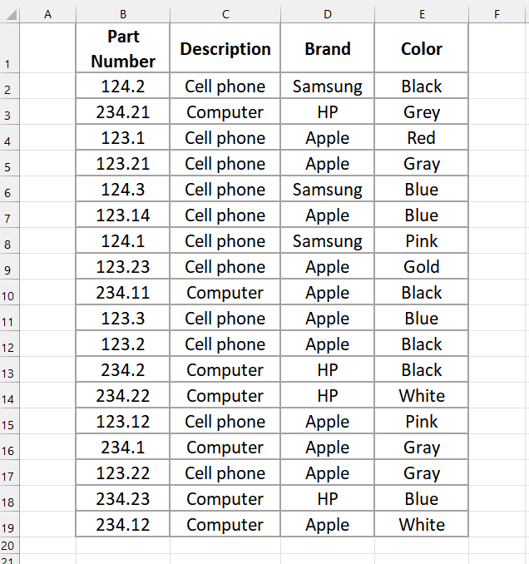

Xmatch
The function Xmatch searches for a specified item in a range of cells and then returns the relative position of that item in the range. This is an upgraded version of the function MATCH.
For example, I would like to find the location of the part number 123.22.
On cell F2 type equal, XMTACH, open a parenthesis, then the first argument is the value we are looking for, 123.22, if the value you are looking for is a text string, put in the quotation’s marks, comma, then select the range where we will look from, B2 to B19, this function default to exact match, just close the parenthesis and press enter. And there we have, 16 rows down is where this part number is.

Find
The function Find locates one text string within a second text string, and returns the number of the starting position from the second text string. It is case sensitive, which means, the string you are looking for, need to be spelled exactly in both strings to be found.
For example.
I want to locate the last name Jones on any of these cells.
On cell C2, type equal, FIND, open a parenthesis, then the first argument is the value that we are looking for, Jones in quotation marks, comma, then select the first cell from this list, close the parenthesis and press enter.
Copy the formula down and let's see the results.
We found Jones only on cell B7 starting at character 6.

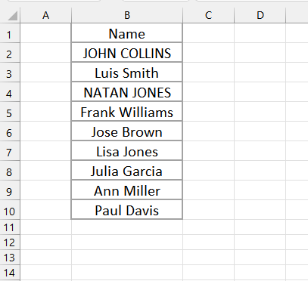

Search
The function Search locates one text string within a second text string and returns the number of the starting position in the second text string.
For example.
I want to locate the last name Jones on any of these cells.
On cell C2, type equal, search, open a parenthesis, then the first argument is the value that we are looking for, Jones in quotation marks, comma, then select the first cell from this list, close the parenthesis and press enter.
Copy the formula to the rest of the cells and let's see the results.
We found Jones only on cell B7 starting at character 6.

